Jeff Scanlon

* 1. 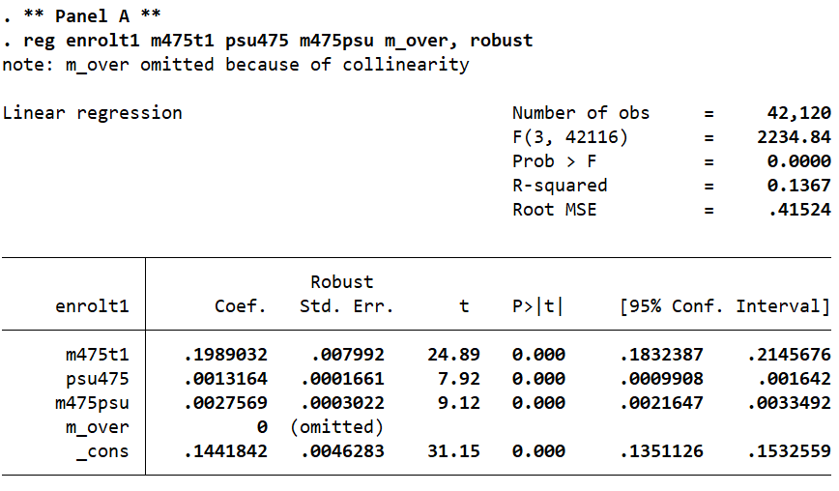
  2. The author is concerned about bias in the data associated with the income level of students and their families. In particular, he is concerned about bias in the exclusion restriction which requires that the PSU score only impacts college enrollment through the channel of loan eligibility/credit access. However, the author thinks there is potential bias because higher PSU scores might also be associated with higher income levels, which itself may be associated with better academic preparation, better access to credit, and stronger preferences for attending college. These unobserved factors, associated with income level, might be alternative channels through which PSU score can impact the college enrollment. This source of bias could positively bias the estimates of the impact of access to credit on college enrollment, by overestimating the effect of access to credit, since the estimate would also include these unobserved effects related to income. Thus, the author attempts to address this bias by performing a fuzzy RD on each income quintile, which thereby estimates the causal effect of credit access at the cut-off for each income quintile. It may be reasonable assumed that such a design could eliminate this income bias if the range of incomes within any individual quintile is unlikely to impact those unobserved factors.
  3. Allowing retakes on a test related to college enrollment can positively bias the treatment effect. This is because students can self-select (choose) to retake the test again a later time. In general, we can make the argument that students who do retake the test again are likely better prepared for the test and will be more likely to achieve the desired and/or cutoff score because they have already taken the test at least once before and therefore know what to expect, they may have put more time into studying, and because of the fact that if they are choosing to take the test again, they may have more motivation to do well on the test and to enroll in college. This is why the author uses an instrumental variable design where the PSU score for the first attempt is an instrument for immediate loan eligibility, since this set-up can reasonably assume that students scoring just above and just below the cutoff on the first attempt are essentially the same in all other ways and that assignment to loan eligibility is as good as random.

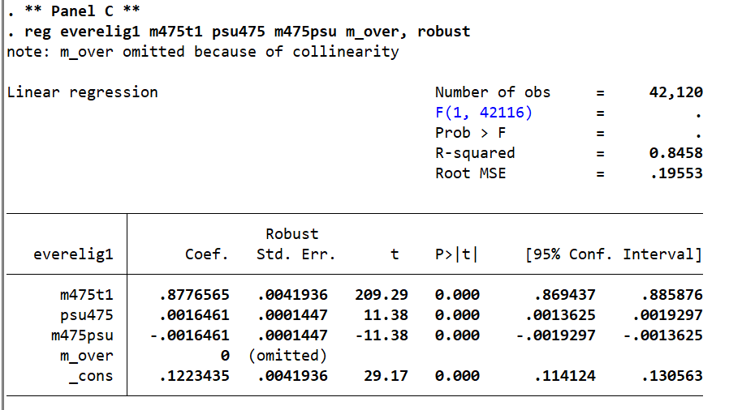  
  
Instrument relevance: The relevance assumption requires the instrument has a causal effect on the treatment, meaning the student’s first attempt PSU score must have a causal effect on if the student is ever eligible for the loan. Panel C of Table 5 reveals that this assumption is valid for quintiles 1-4 (p ≤ 0.01), but not valid for quintile 5.  
  
Exogeneity: This assumption requires that the explanatory variables are not correlated with the error term, meaning there are no unobserved or omitted variables that are influencing both the explanatory and outcome variables. The author largely addresses concerns over endogeneity by performing separate regressions for each quintile and also by using an instrumental variable design.

* 1. 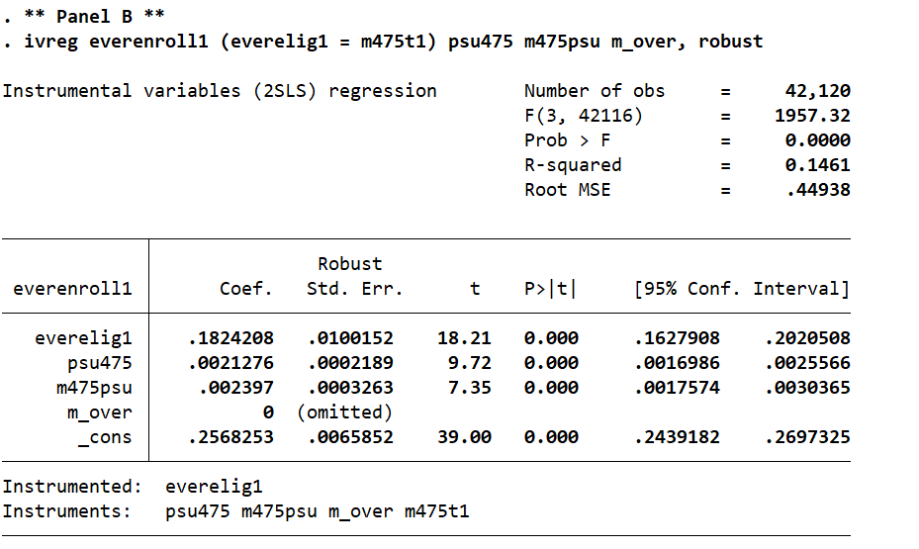  
     External validity asks whether the causal effects observed in this study can be generalized to other contexts outside of this study. The author seems to suggest that the causal effect of loan eligibility through the loan program would likely be greater in Chile (the country of study) compared to many other countries around the world. This is because, as the author states, Chile has relatively high tuition prices compared to many other countries and does not offer programs to “price-discriminate” and support low-income families with tuition-reductions or scholarships (page 609). Thus, the causal effect is likely to be greater in Chile than in other countries because not getting access to a loan may become very prohibitive for Chilean students to enroll in college, while receiving loan access may become perhaps the only avenue to enroll. In other countries, like the U.S., a merit-based loan (measured through a test), may not be the only avenue since need-based loans or scholarships also exist. Thus, the results of this study are best generalized to other countries that have higher education funding schemes and aid programs that are similar to those of Chile’s.  
       
     The results from the 2SLS shown above give evidence that the study results are *internally* valid because the p-values for each of the estimates are very close to zero. However, all of the considerations above must be taken into account when deciding what types of settings the results of this experiment can be generalized to.
  2. Figure 3 is a close graphical representation of the regression in Part A.  
     Figure 4 is a close graphical representation of the regression in Part B.
  3. The PSU score density graph (the lower graph of Figure 6) can be used to observe whether or not it appears that score manipulation has occurred. A vertical line at score x=475 is drawn. If score manipulation has occurred, we would expect to see a discontinuity before and after this cutoff. Specifically, we would expect to see a decrease in density right before the cutoff and an increase in density just after the cutoff. However, no discontinuity is observed. The density appears to be continuous across this threshold (as mentioned on page 590), thus there is evidence that no score manipulation has occurred.
  4. 